You Are Invited To The
Cape Fear Ballroom Dancers
29th Anniversary Dinner-Dance
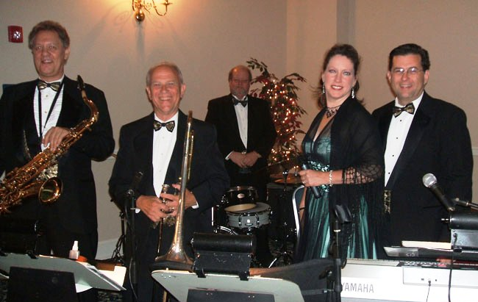

With Music by the Duke Ladd Orchestra
Saturday, September 17, 2022
Highland Country Club
6:30 Social 7:00 Dinner
7:30 – 10:00 Dancing
Admission – $100.00 per person
$25.00 discount for CFBD members

Ladies: Cocktail Dress, Semi-formal, or Formal Gentlemen: Tuxedo (preferred)

Pre-Paid Reservations required by Sep 12 – check payable to: Cape Fear Ballroom Dancers.
Mail check & reservation form to: Cape Fear Ballroom Dancers, PO Box 1359, Fayetteville, NC 28302.
For more information, call 910-987-4420 or go to www.capefearballroomdancers.org

Please specify below any special dietary requirements; e.g. allergies, vegetarian meal, etc. People may be responsible for any additional cost for a special meal.

Cut here

Name: __________________________________________ $100 $75 CFBD member

Name: __________________________________________ $100 $75 CFBD Member

Please list names of those who wish to sit at the same table (limited to 8 people):

If your reservation is received after the 100 person limit has been reached, please give us a telephone number where we may notify you: ____________________________

